

**Report**

**Project:**

**Intra Checker Game**

**Group members**

* **Hassan Raheem**
* **Abdul qayyum**

**Introduction**

Checkers, also known as draughts is a group of strategy board games for two players which involve diagonal moves of uniform game pieces and mandatory captures by jumping over opponent pieces. Checkers is developed from alquerque The term "checkers" derives from the checkered board which the game is played on, whereas "draughts" derives from the verb "to draw" or "to move".

The game is played on an 8x8 grid board, essentially a checker board. Each player starts with 12 pieces, placed on the dark squares of the board closest to them.The objective of the game is to capture all the opponent's pieces by jumping over them.

**The Rules of the Game**

The rules of the game are the standard rules for a draughts or checkers game, that is each color can move one piece one square at a time per turn, in a diagonal direction unless they are in a position to take an opponent's piece at which point they will jump over the piece to remove it from the board. The game is programmed so that if a player or the computer is able to take a piece then that piece must be taken. This also applies to any piece that can be taken in the same move. The computer will automatically take all the available pieces with a single move but the player must drag and drop the piece taken over each piece in such a way that they are taken until the piece cannot take any more pieces. The program will automatically highlight the pieces that are available to be taken in any given move as long as the option to use the highlights is checked.

The game additionally has an inbuilt rule that says if no pieces are taken for more than twenty moves, then the game is declared a draw. This is done to prevent endless moving backwards and forwards at the end of the game.

**Required Tech Stack:**

* Java
* Sockets
* Threading
* Java vfx

**User interface**

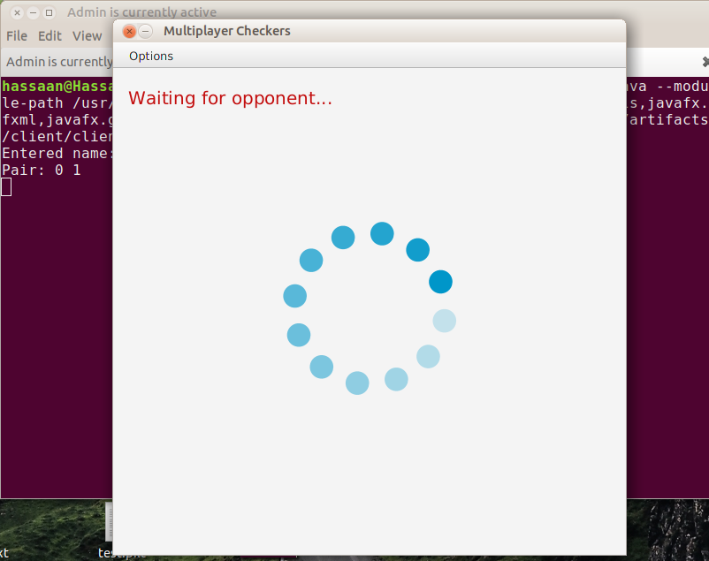

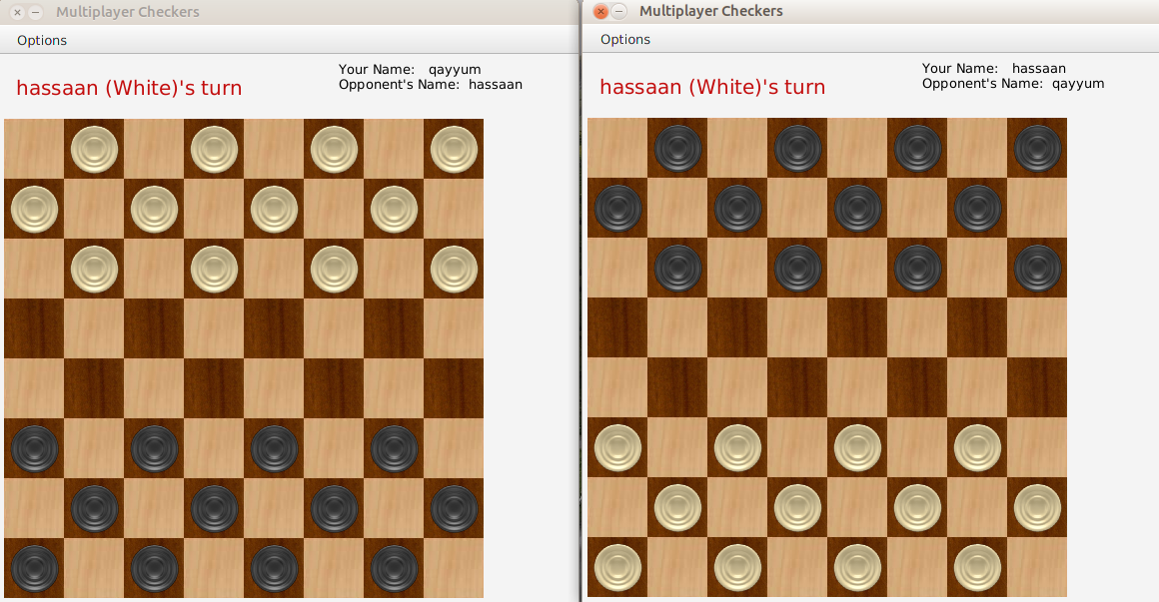

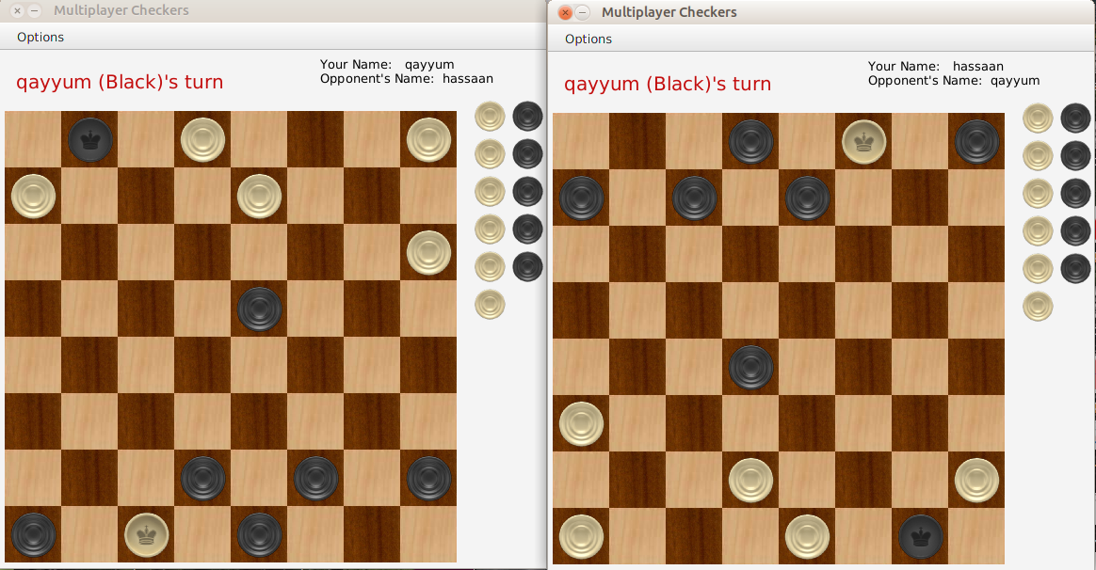

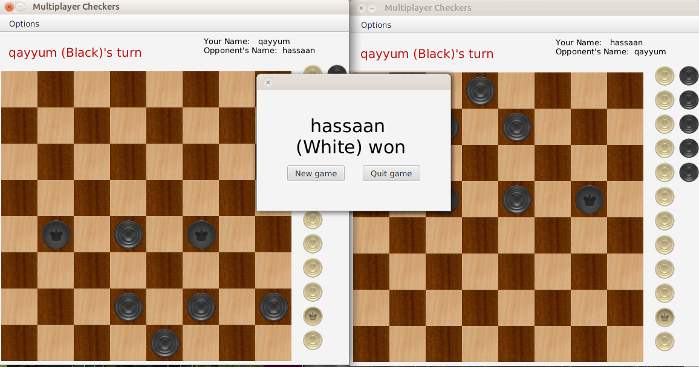

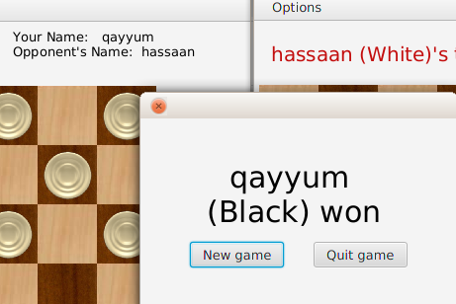

**Conclusion**

The aim of this project was to develop a networking based program that works in a more natural way than the standard idea of how a draughts game should work. This was done by aiming more for a system of calculating the moves on a basis that relied not on a total omniscient idea of controlling everything that occurs on the board and having a fixed response or series of responses preprogrammed into the code but for the code to consider each move in isolation from every other move and to make its judgments based on the best move in the given situation. This is coupled with the concept of a program having its own history which is able to influence but not necessarily dominate the individual decisions that are made about each move.